GRADE 7 ACCELERATED · UNIT 2 · LESSON 2
Square Values and Square Roots
Additional Practice 7A.02.02 ANSWER KEY

1. Label the three parts of the radical expression.
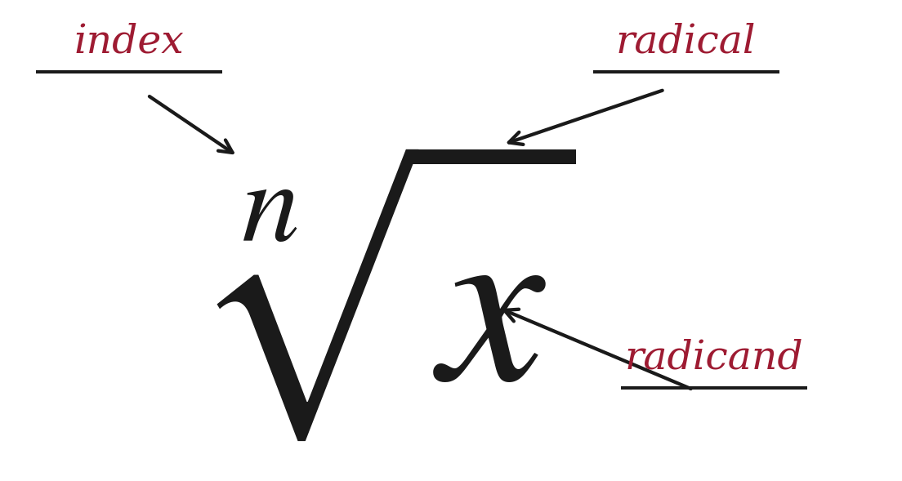
An index of 2 is never written. Any other index always is.
2. Fill in both boxes. They do not get the same answer.
The radical on its own | The equation
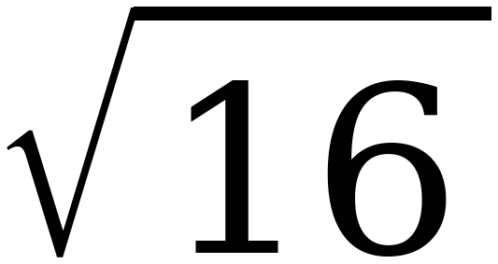 | x² = 16
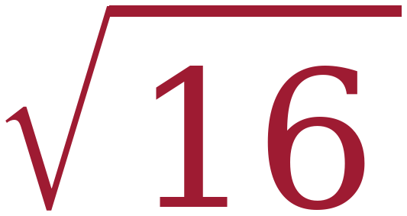 = 4 | x = ± = ±4

Left box: one number, the positive one. Right box: every value that works, and there are two.
For questions 3 through 6, find the value.
3. 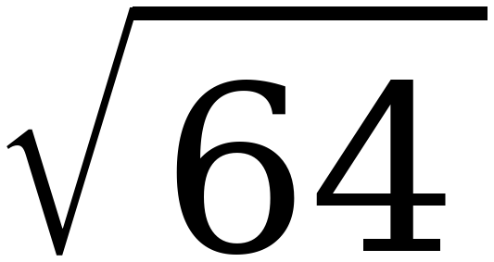
8 because 8 × 8 = 64

4. 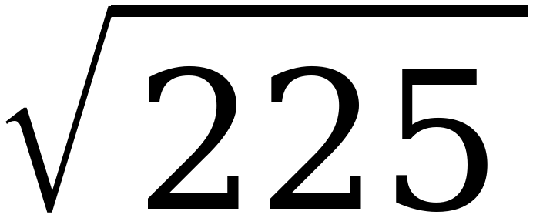
15 because 15 × 15 = 225
225 is the largest perfect square the Grade 8 FAST will ask about.

5. 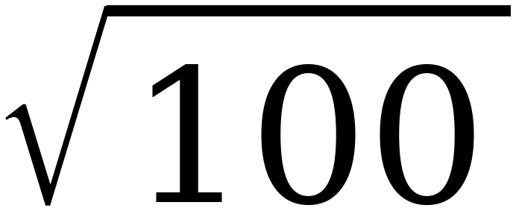
10

6. 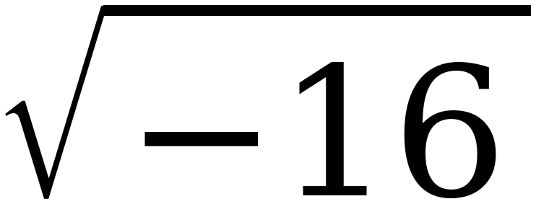
No real value.
Not 0 and not −4. Nothing real squares to a negative number.

For questions 7 through 10, find every real solution of the equation.
7. x² = 25
x = ±5

8. 196 = a²
a = ±14
The variable is on the right. Nothing changes.

9. n² = 0
n = 0
One solution, not two.

10. x² = −100
No real solution.
Same refusal as question 6, asked about an equation instead of a radical.

11. Select ALL of the values below that make x² = 144 true.
☒ | 12 | ☐ | 72
☒ | −12 | ☒ | 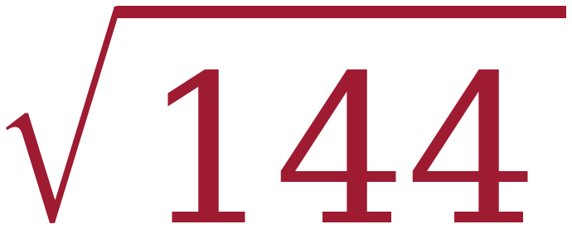
☒ | − | ☐ | 288

√144 is 12 and −√144 is −12, so four boxes are ticked but only two numbers are named. 72 is 144 ÷ 2 and 288 is 144 × 2 — both are the halving-and-doubling error.
12. Owen writes the statement below on his paper.
= ±10
Explain what is wrong with Owen's statement, then write the two correct statements it should have been.
The radical symbol means the positive square root only, so the statement is false as written.
Correct statement 1: 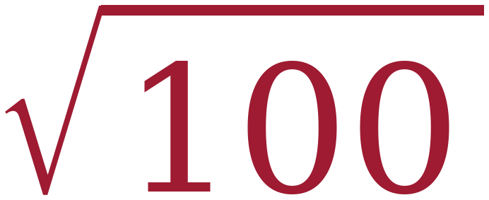 = 10
Correct statement 2: x² = 100 has two solutions, x = ±10
Owen has the arithmetic right and the notation wrong. Both halves are needed for the point.

